

**Boston University**

**Electrical & Computer Engineering**

**EC464 Capstone Senior Design Project**

User Manual

**Aerobatic BlackBox**

Submitted to

Dr. Kenneth D. Sebesta

CyPi Ltd.

859-648-0272

[kenn@cypiltd.com](mailto:kenn@cypiltd.com)

by

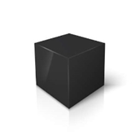

Team 9

Aerobatic BlackBox

Darcy Meyer [darcym@bu.edu](mailto:darcym@bu.edu)

Pai Liu [paiii@bu.edu](mailto:paiii@bu.edu)

Wenjun Ma [wjm123@bu.edu](mailto:wjm123@bu.edu)

Radhey Patel [rexu6@bu.edu](mailto:rexu6@bu.edu)

Xinyu Liu [xinyubu@bu.edu](mailto:xinyubu@bu.edu)

Submitted: Apr 26, 2022

# Table of Contents

**Table of Contents** **2**

**Executive Summary** **3**

**Introduction** **4**

**System Overview and Installation** **5**

Overview Block Diagrams 5

User Interface 6

Physical Description 6

Installation, Setup, and Support 8

Hardware Installation 8

Software Installation 9

Simulator Installation 9

**Operation of the Project** **10**

Normal Operation 10

Abnormal Operation 10

Safety Issues 10

**Technical Background** **12**

System Overview 12

Sensors 12

Software (Image Processing) 12

Reading the airspeed dial 12

Reading the positions of the flight stick and rudder pedals 13

**Relevant Engineering Standards** **14**

**Cost Breakdown** **20**

**Appendices** **22**

Appendix A – Specifications 22

Appendix B – Team Information 23

# Executive Summary

Aerobatic performances are very different from ordinary flying tasks. General pilots use scientific methods to avoid risks during training, while aerobatic pilots take the initiative to face risks and use their lives to challenge the limits of aircraft performance and flying skills. In the field of aerobatics, there is no limit to the exploration of pilots' flying skills. In different aerobatics, the aircraft's flight status, altitude, speed, direction, and overload parameters change drastically. The pilot must be aware of the flight status at any time, understand the changes in motion parameters, and control the aircraft to move on a predetermined trajectory in a timely and accurate manner. During competition training, ordinary avionics cannot record and replay 3D demonstrations of flight training, and pilots cannot make precise movement adjustments.

In order to help pilots to understand the status of the aircraft, the AHRS came into being, which can help pilots understand the real-time aircraft attitude. However, this system lacks 3D playback of aerobatics, cannot help the pilot to watch the aircraft attitude from the judge's point of view, and cannot record real-time pilot input, which does not meet the needs of aerobatic training.

Our Aerobatic Black Box addresses these issues by delivering hardware, constituting AHRS, INS, GPS and a camera to collect pilot input, and a software component allowing pilot replay 3D demonstration of flight training, and also provides pilot input corresponding to every maneuver. Aerobatic BlackBox is specially designed for introductory aerobatics pilots and aerobatics training. This system will allow pilots to observe different angles of flight attitude for the next flight adjustment, and also solves the lack of digital AHRS in some aircraft, maneuver log and greatly reduces the difficulty of aerobatics training.

# Introduction

During aerobatic competition the aircraft's flight status, altitude, speed, direction, and overload parameters change drastically. The pilot must be aware of the flight status at any time, understand the changes in motion parameters, and control the aircraft to move on a predetermined trajectory in a timely and accurate manner. During competition and training, AHRS will help pilots understand the real-time aircraft attitude, however this device cannot record and replay 3 demonstrations of flight training, and pilots cannot make precise movement adjustments based on ordinary avionics.

Under this premise, the client put forward the following requirements to us: First, the equipment must be able to record flight data (including altitude, GPS, and flight attitude). Second, the equipment must be able to record the pilot's input to the aircraft. Third, the equipment must be able to replay 3D flight simulations to help pilots adjust flight movements. Fourth, flight simulation must be able to switch perspectives to help pilots observe aerobatics.

Our Aerobatic Black Box will address client’s issues by providing a hardware part which contains AHRS, INS, and cameras to collect pilot input, and a software part which allows pilots to replay 3D demonstration of flight maneuvers, and also provides pilot input corresponding to every maneuver. When collecting pilot input, we are faced with the problem that the aircraft does not have a collection interface, so we innovatively use image recognition technology to collect airspeed and pilot input.

The Aerobatic Black Box is specially designed for introductory aerobatics pilots and aerobatics training. This system will allow pilots to observe different angles of flight attitude for the next flight adjustment, and also solves the lack of digital AHRS in some aircraft, and greatly reduces the difficulty of aerobatics training.

# System Overview and Installation

## Overview Block Diagrams

Hardware Block Diagram:

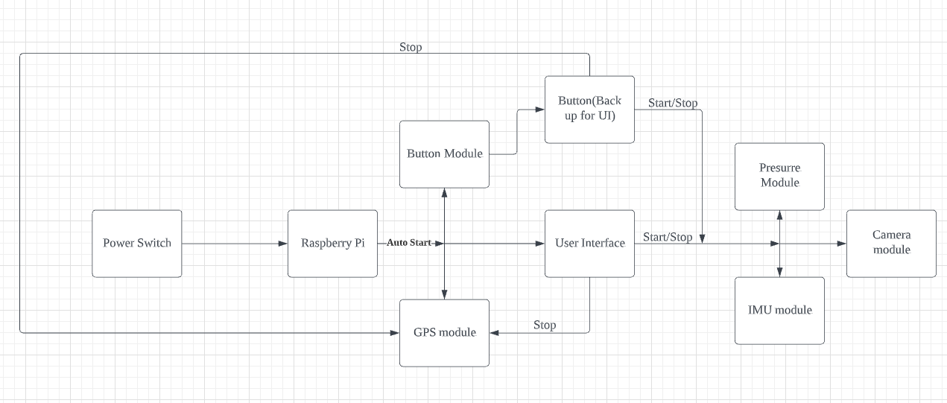

Software Block Diagram:

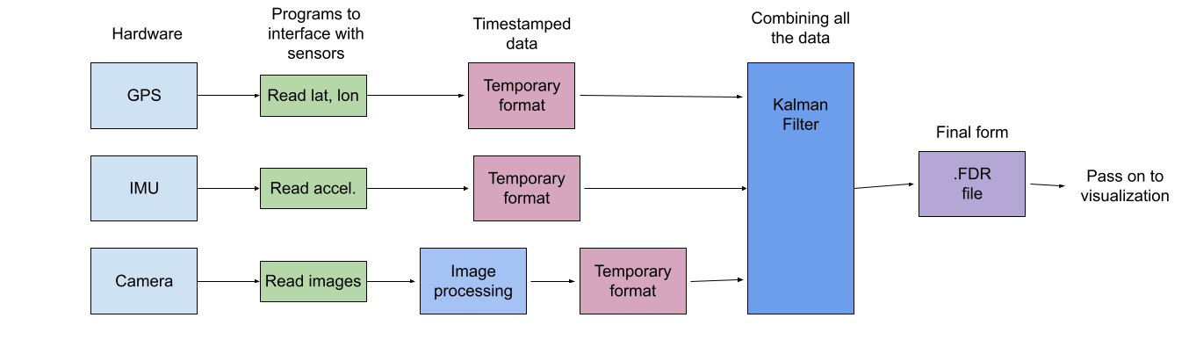

## User Interface

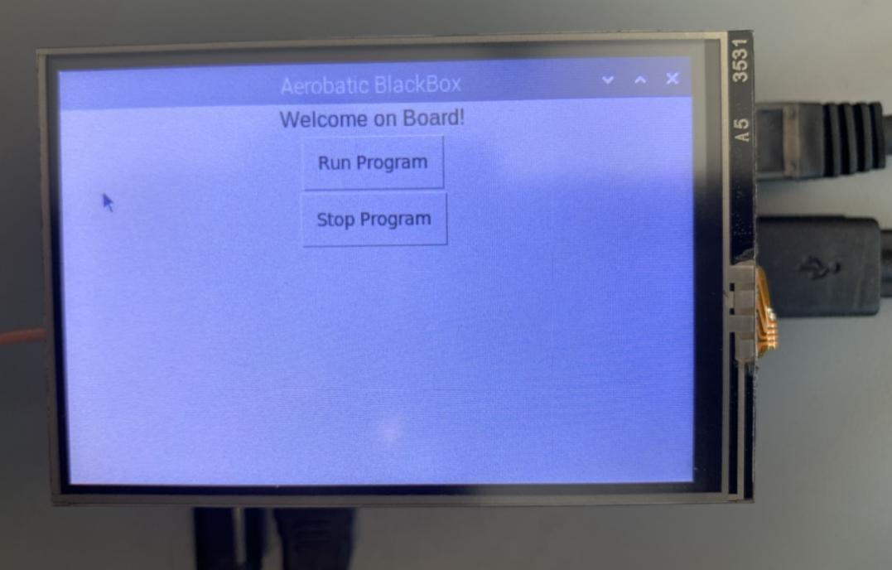

The project automatically starts the GPS module, since the GPS module needs an initializing time to start, automatically starts the button module enabling receiving button inputs, and automatically starts the UI module. After the GPS module is ready to collect data, an LED light turns on and a message is displayed in the user interface. Then, the user can touch the screen to select either “Run Program” which activates data recording, or “Stop Program” which stops data collection.

## Physical Description

In this section, the BlackBox’s pictures and 3D module are provided below.

Top view:

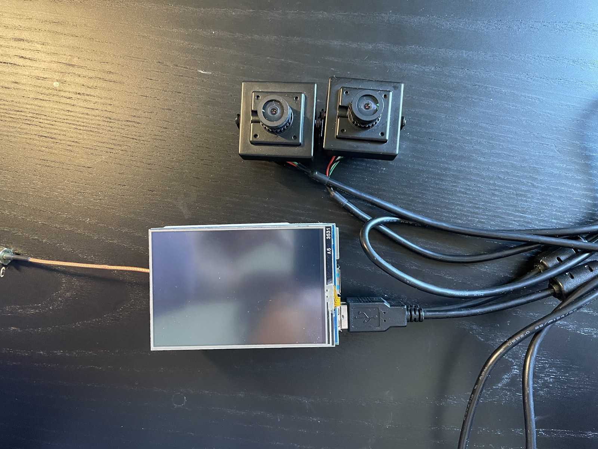

Left view:

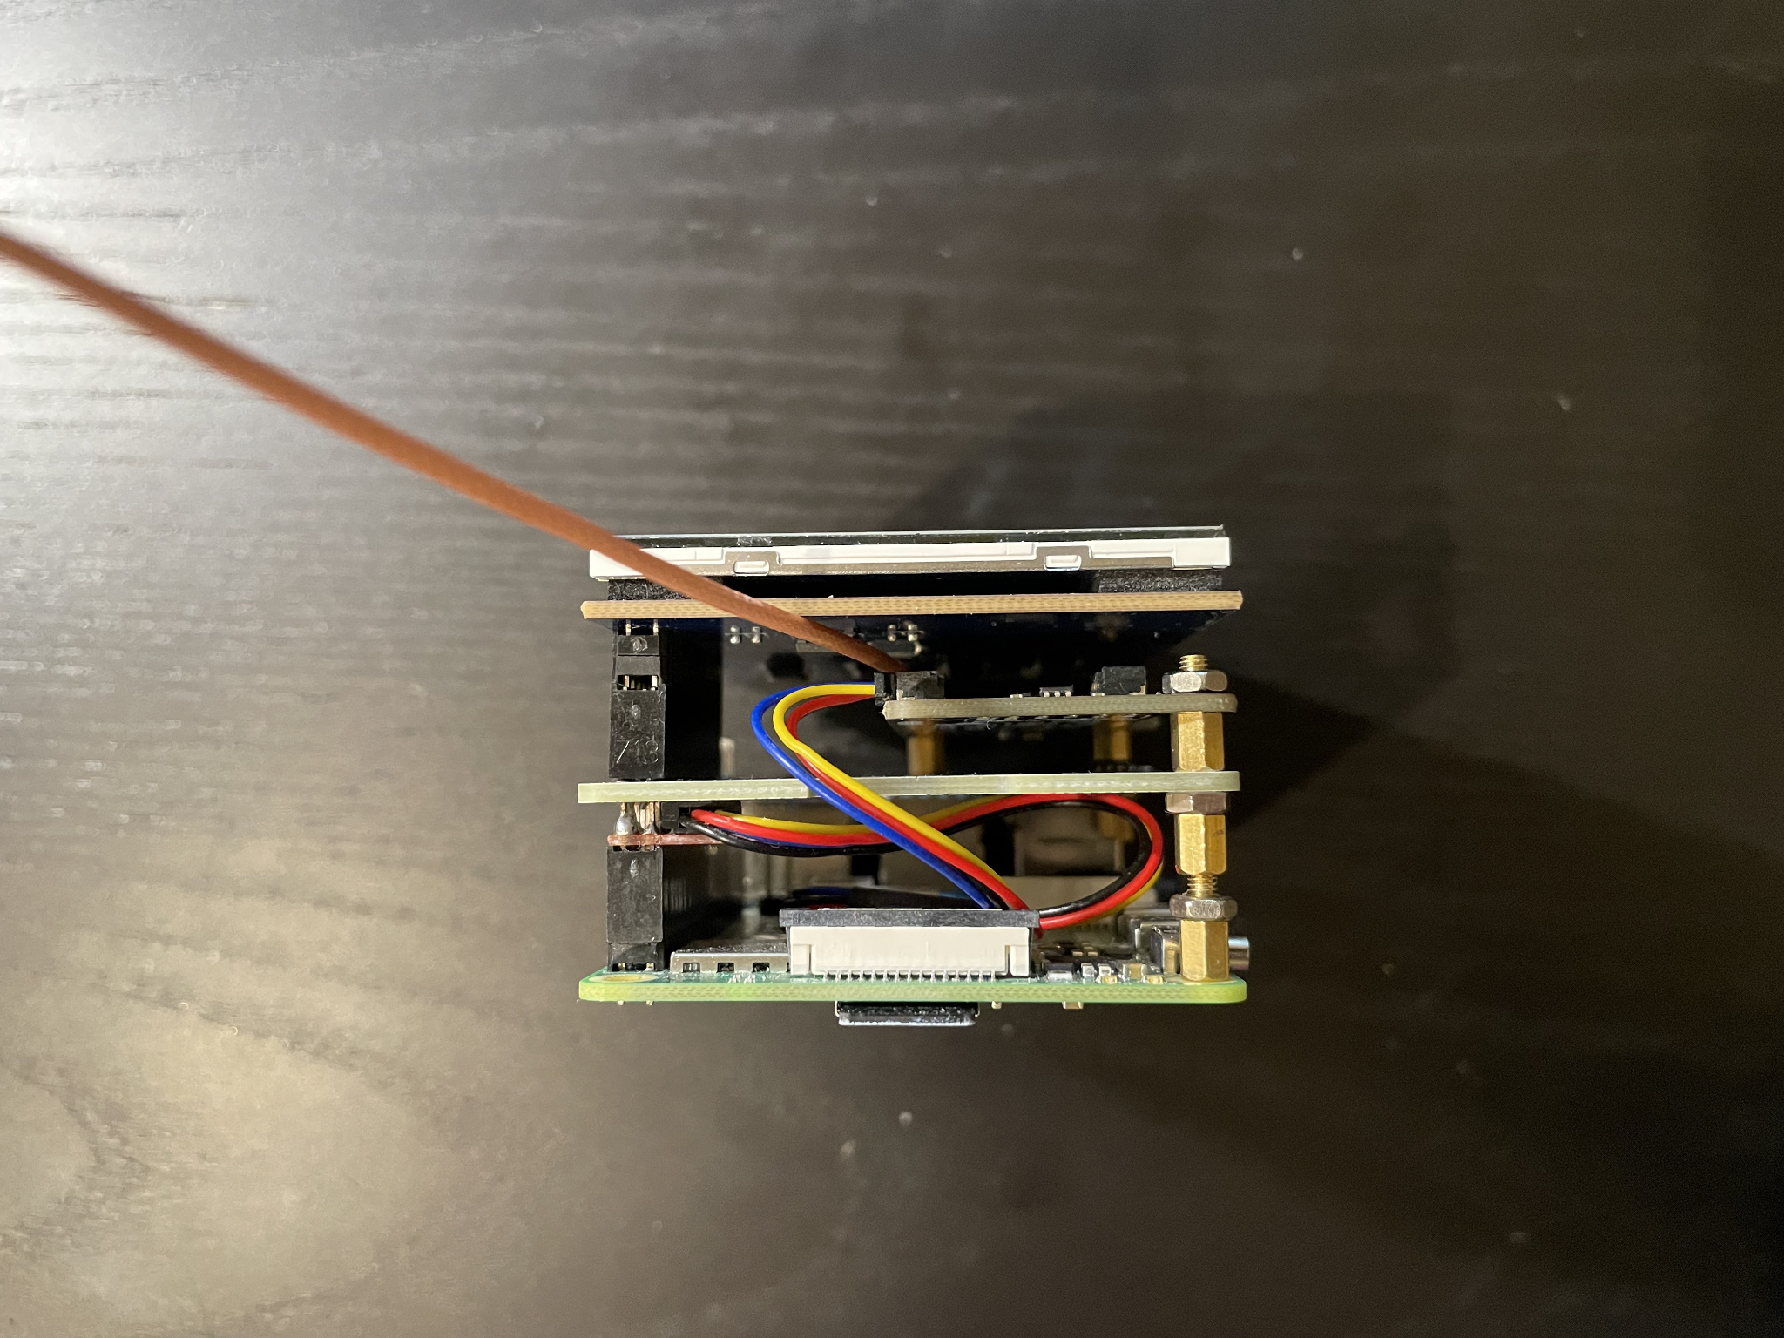

Right View:

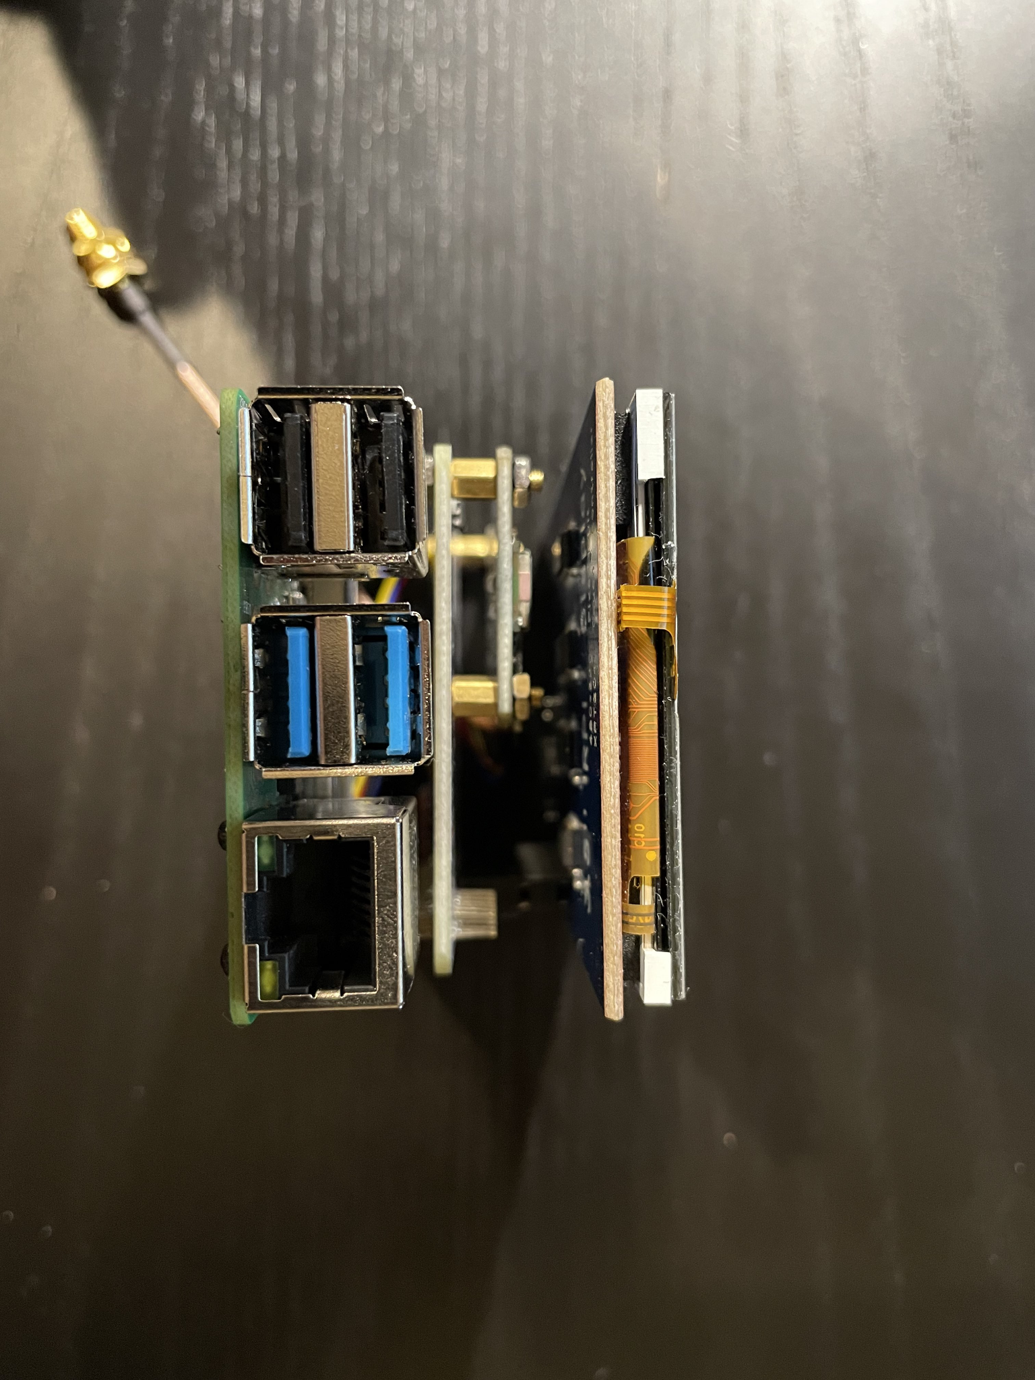

Front View:

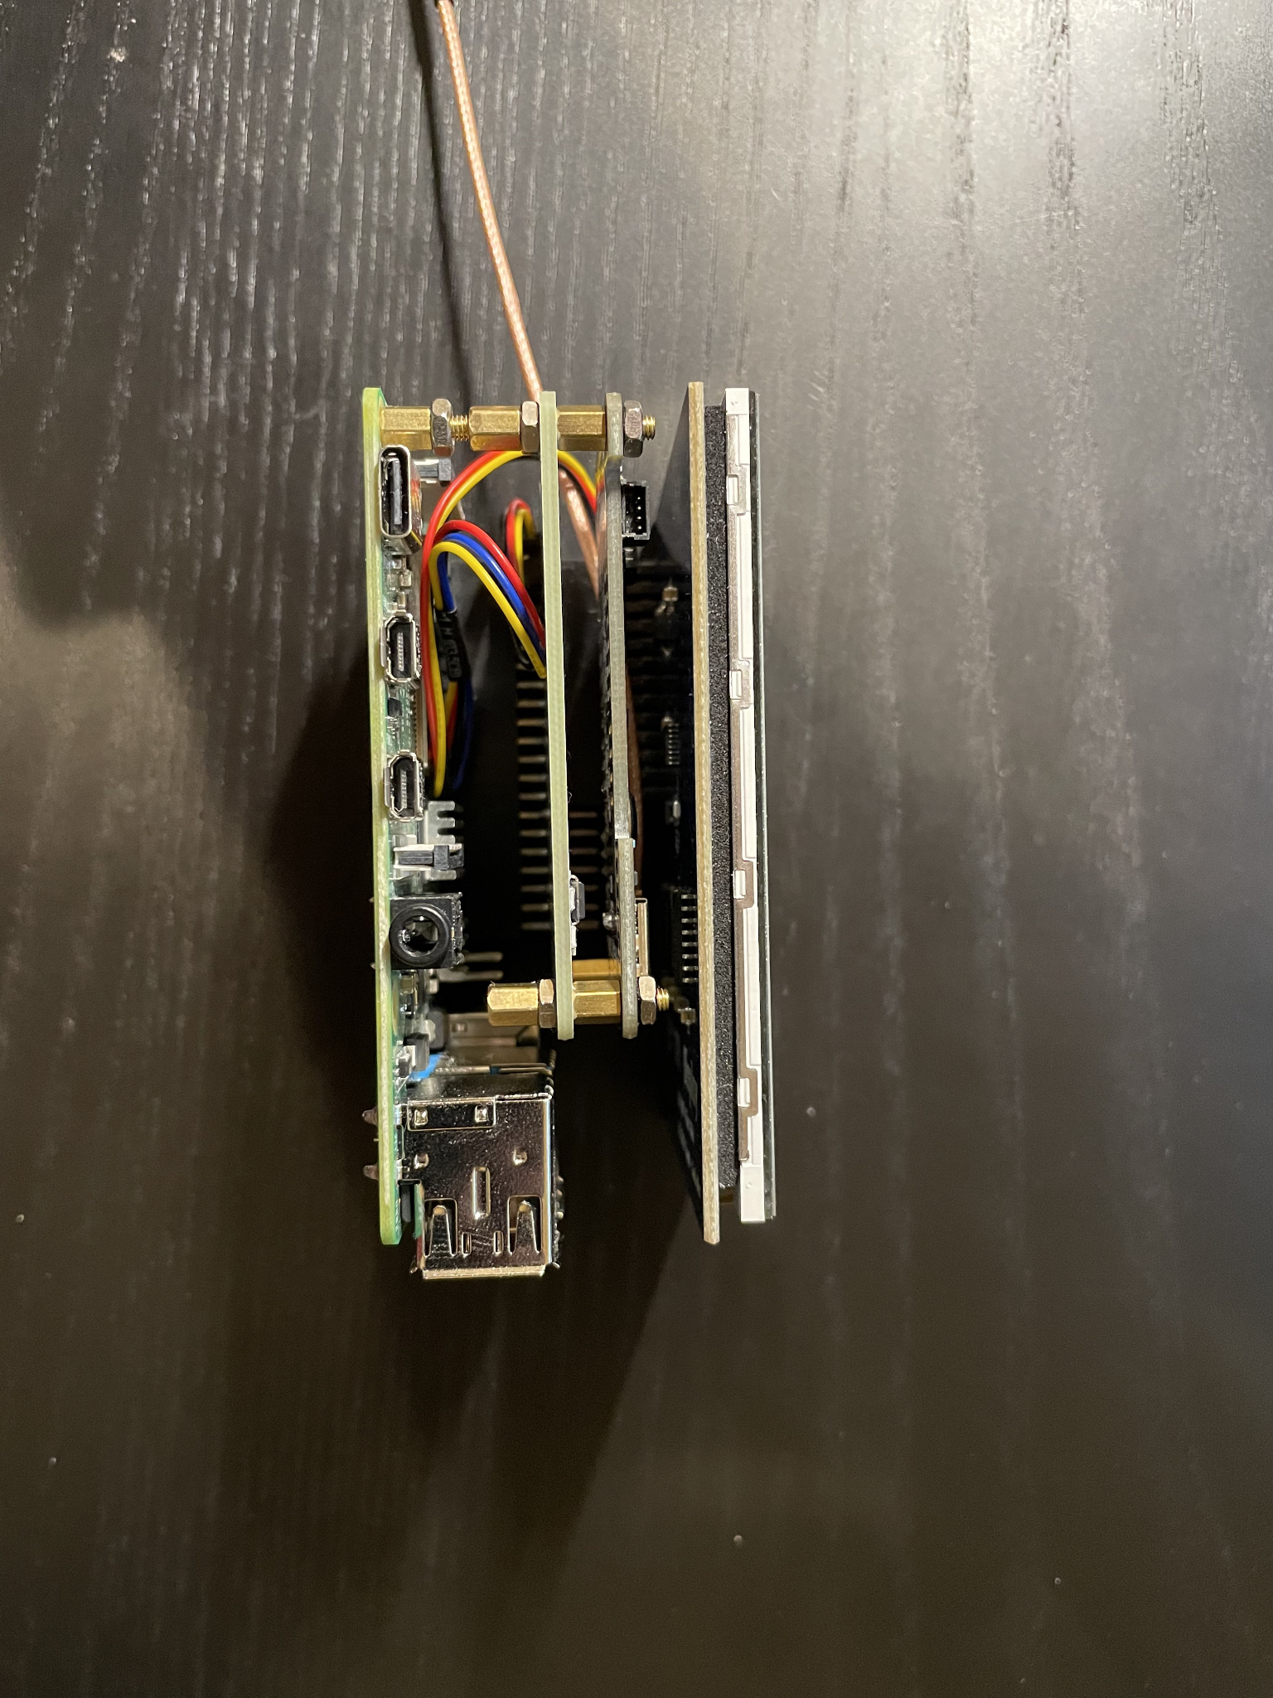

Bottom View:

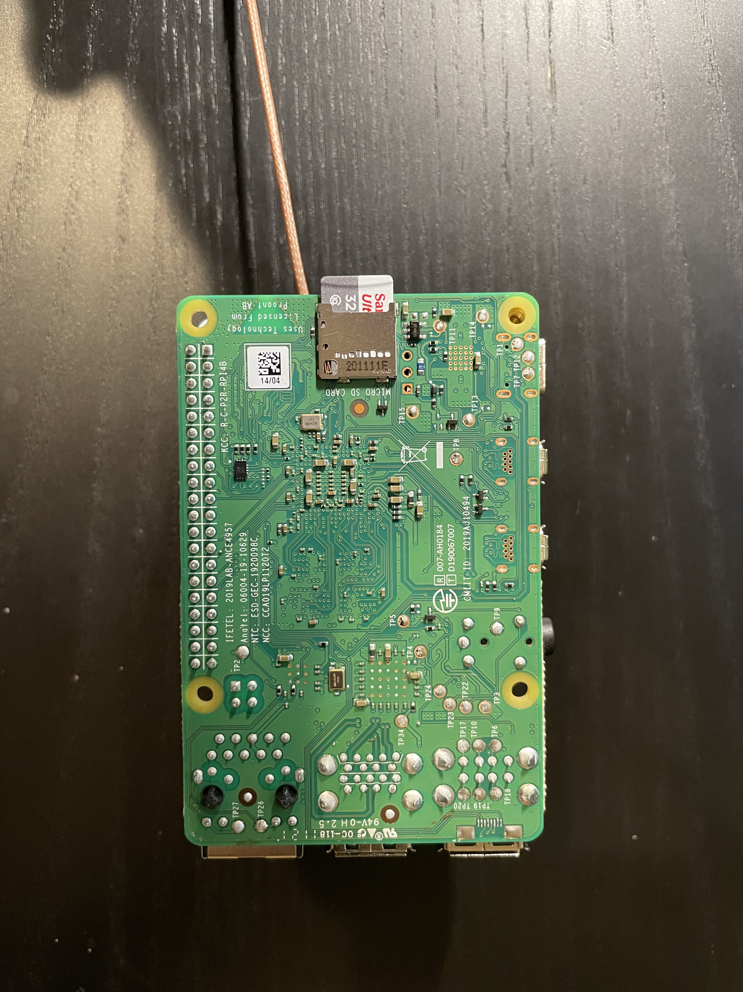

Case:

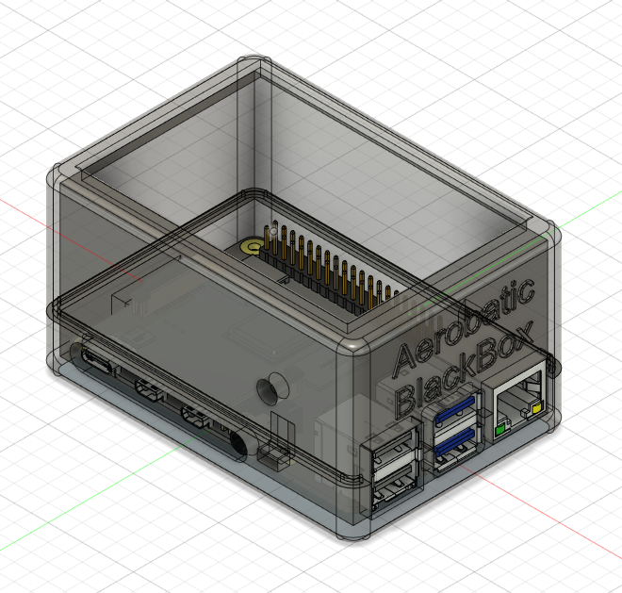

## Installation, Setup, and Support

### Hardware Installation

The hardware assembly and installation is mainly divided into two parts: the first part is installing the blackbox body, and the second part is installing the cameras.

1. Use Velcro to fix the black box to the top of the inside of the aircraft, and make sure that the screen of the black box is facing down and the usb port is facing the nose of the aircraft.Then connect the external antenna and make sure the antenna is placed close to the front windshield.
2. Camera installation: The No. 1 camera should be fixed with Velcro in a position where it can clearly and unobstructedly capture the airspeed indicator, and the No. 2 camera should be installed in the co-pilot position using a Velcro, where it can clearly and unobstructedly record the aircraft flight stick and rudder cable. Then secure the extra wire and insert the cameras’ USB connectors into USB ports 1 and 2 of the black box.
3. Connect the power and press the power button to start the black box.

### Software Installation

There are several necessary packages that need to be installed.

1. Install python and python3: sudo pip3 install python & python3
2. Enable the I2C port:

sudo raspi-config

Select Interfacing Options > I2C.

Select Yes when prompted to enable the I2C interface.

Select Yes when prompted to automatically load the I2C kernel module.

Select Finish.

Select Yes when prompted to reboot.

1. Enable the Webcam:

sudo raspi-config

Select Interfacing Options > web camera.

Select Yes when prompted to enable the web camera interface.

Select Yes when prompted to automatically load the web camera module.

Select Finish.

Select Yes when prompted to reboot.

1. Install OpenCV:

sudo pip install opencv-contrib-python

sudo pip install virtualenv virtualenvwrapper

### Simulator Installation

The simulation software used to visualize the stored .fdr file is Xplane 11 (2017)

1. For a trial version visit the desktop trial version on the website [here](https://www.x-plane.com/desktop/try-it/) (https://www.x-plane.com/desktop/try-it/). Although, a [full purchase](https://www.x-plane.com/desktop/buy-it/) (https://www.x-plane.com/desktop/buy-it/) would be recommended to unlock most of the environments as well as aircraft designs developed by Laminar research.
2. Save the “X-Plane 11 Installer” and initialize it once downloaded.
3. Open the “Xplane 11 Installer.exe”
4. Select “Run the Xplane 11 Demo“
5. Select “Load a Saved Flight”
6. Select Root Location for the file to be initialized from the Raspberry Pi.

# Operation of the Project

## Normal Operation

Before Taking Off：

1. When the user is ready to start the flight recording, just hit the power button of the raspberry pi. The user interface will pop up automatically. Note: This process only activates the user interface and the GPS sensor; the IMU sensors and cameras are not activated.
2. When the user interface is started, the green LED light will start blinking, which means the GPS sensor is searching for the GPS signal. Note: Searching for the GPS signal will take 5-25 minutes depending on the weather and the operating environment.
3. When the green LED light stops blinking, the user can click Start Program to start the recording. The user interface will show the message “Program Start!” to confirm that all sensors are activated.

After Landing:

1. When the user is ready to stop the flight recording, just click Stop Program to stop the recording. The user interface will show the message “Program Stop!” to confirm that all recording has stopped.
2. After removing the flash drive, the user can insert the flash drive into a computer which has the Xplane11 simulator installed.
3. After inserting the flash drive, the user can click “Load File” under the menu bar to watch the replay.

## Abnormal Operation

Hardware:

* If the UI doesn’t pop up, the user can use two physical buttons on the side of the case to start and stop the program.
* If the touch screen does not turn on after powering on the raspberry pi, connect the raspberry pi to a normal monitor through the micro-hdmi to hdmi cable to check if the desktop is successfully loaded on a regular monitor.

GPS Sensor:

* If the green LED light is blinking for more than an hour, try to move the device to an open area that has a clear view of the sky.

## Safety Issues

1. Our device so far has only been tested to operate with car cigarette lighters and North American power standards, and might not work as well with other countries’ power ratings. Users are advised to make sure that our device is connected to an outlet with surge protection or the car cigarette lighter. As of now, it is not advised to use our device outside of North America until it is tested or certified in other countries.
2. Users should avoid removing the flash drive before stopping the program. It might cause data loss and damage to the sensors.
3. Users should avoid powering off the raspberry pi before stopping the program. It might cause data loss and damage to the sensors as well.

# Technical Background

## System Overview

Our project uses a Raspberry Pi and several sensors to fulfill its hardware functionalities. The Raspberry Pi platform was selected because it essentially functions as a general purpose computer with a Linux operating system. Python was used as the main programming language throughout the project to control the sensors and cameras. Pilots’ inputs and airspeed dial detection was made possible with a USB camera. The project also uses a 3V LED light to indicate GPS status since the time required to find GPS signals varies according to different operating circumstances.

## Sensors

A BerryIMU sensor is used to detect the aircraft’s roll, pitch, yaw, altitude and longitude during the flight. We chose this sensor because it includes an IMU sensor, a GPS sensor, and a pressure sensor. We can directly record the IMU data and GPS data from this sensor without any extra cables. Additionally, we can use the embedded pressure sensor to get the altitude data.

Cameras are used to capture the airspeed dial and the movement of the rudder pedals and the flight stick. We chose this sensor since it is connected through a USB cable. It is convenient for us to install them in the cockpit to get the precise data of the airspeed dial and the rudder pedals.

## Software (Image Processing)

### Reading the airspeed dial

Classical computer vision techniques are used to transform an RGB image of the airspeed dial into a numerical airspeed reading.

First, color segmentation using KMeans and circle detection using the opencv-python Hough circle detection function are used to detect groups of pixels within the airspeed dial that could represent the dial needle:

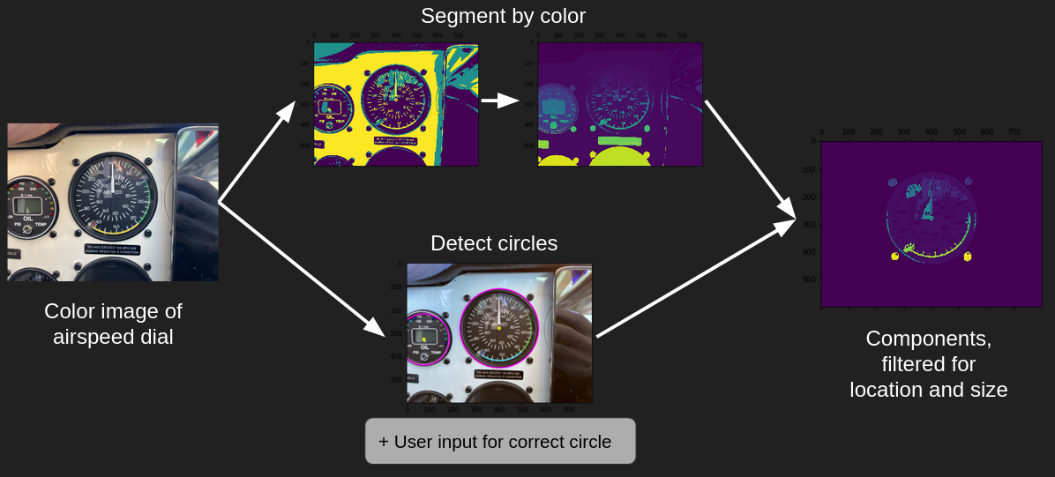

Then, Hough line detection is performed on several candidate groups of pixels, and the pixel group that is least circular is chosen as the true dial. The angle of this line is used as the angle of the dial.

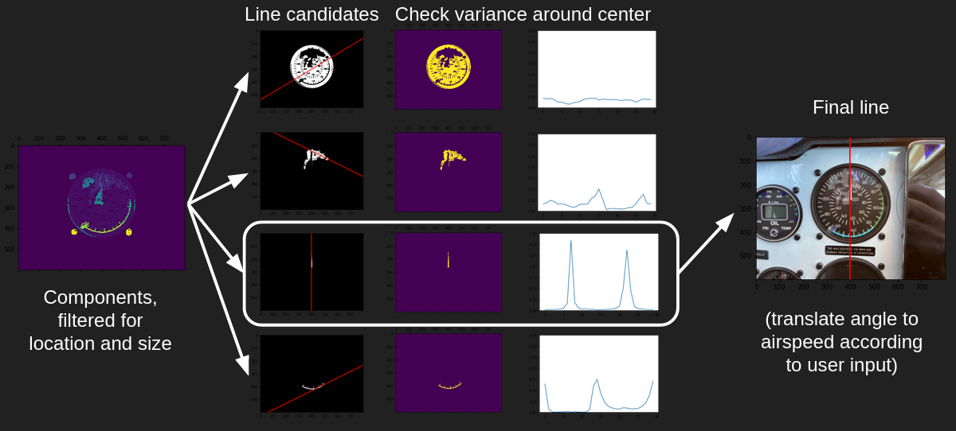

The user must input the mapping from dial angle to airspeed reading as part of the installation of the airspeed dial camera. This mapping is used to get the final airspeed reading.

### Reading the positions of the flight stick and rudder pedals

The positions of the flight stick and rudder pedals are detected by tracking the location of a piece of colored tape on each of the cables that move in response to the pilot’s actions. The flight stick’s position has two degrees of freedom, and the rudder pedals have one degree of freedom.

The differences between successive RGB images are used to detect the relative movement of the tape on the cables. As part of installation, the pilot needs to provide reference images of the extreme positions of the flight stick and rudder pedals.

# Relevant Engineering Standards

For our IMU module, we use an I2C port to connect the sensor and the raspberry pi, and we use a text file to store the data from the sensor.

For our GPS module, we use an I2C port to connect the sensor and the raspberry pi, and we receive the GPS data from the sensor through the NMEA sentence.

For our cameras, we use USB ports to connect the cameras and the raspberry pi, and compress the frames by using 4-character code of codec “MJPG” and export the video under the .avi form.

The Flight Data Recorder file (.fdr file) standard is used to record the flight data based on the guidance of the Federal Aviation Administration and National Transportation Safety Board for commercial flights. Moreover, the current application system makes alterations in the sequencing of the data by dividing it into 2 segments: Static and Time-Series.

1. Static Variables are initialized at the start of the flight and include:

| *Description* | *Notation* |
| --- | --- |
| any comment | COMM |
| the aircraft file to use, with full directory path from the X-Plane folder (ex: Aircraft/Heavy Metal/Boeing 747.acf). | ACFT |
| tail number of the aircraft (ex: N8141Q). Must come immediately after the ACFT line. | TAIL |
| ZULU time of the beginning of the flight (ex: 18:54:32). | TIME |
| date of the flight (ex: 03/05/02). | DATE |
| sea-level pressure during the flight in inches HG | PRES |
| wind during the flight in degrees then knots (ex: 230,17). | WIND |
| the actual takeoff or touchdown logitude, latitude, and elevation in feet for calibration to X-Plane scenery. (ex: -118.34, 34.57, 456). | CALI |
| time to play a warning sound file, with full directory path from X-Plane itself to the .wav file (ex: 10,Resources/sounds/alert/1000ft.WAV) | WARN |
| time & text to be read aloud by computer speech synthesis software (10,Copilot left the cockpit here). | TEXT |
| time at which a text marker will appear in the time slider (ex: 15,Approach began here). | MARK |
| highlights the flight path at the specified time, for a specified duration (ex: 10.5) | EVNT |
| comma-delimited floating-point numbers that make up the bulk of the .fdr data (see explanation table below) | DATA |

1. Time-Series Variables are allocated/calculated during the flight from the sensor data and start with the “DATA” tag to initialize data reading:

| *Notation* | *Description* | *Example Value* |
| --- | --- | --- |
| time secon | time in seconds from the beginning of the recording | 1 |
| temp deg C | temp in degrees celsius of the ambient air near the airplane at current altitude | 45 |
| lon degre | longitude in degrees | –117.20 |
| lat degre | latitude in degrees | 34 |
| h msl ft | height above mean sea level in TRUE feet, regardless of any barometric pressure setting or other errors | 4010 |
| h rad ft | radio altimeter indication | 0 |
| ailn ratio | aileron deflection in ratio –1.0 (left) to +1.0 (right) | 0 |
| elev ratio | elevator deflection in ratio –1.- (nose down) to +1.0 (nose up) | 0 |
| rudd ratio | rudder deflection in ratio –1.- (left) to +1.0 (right) | 0 |
| pitch deg | pitch in degrees, positive indicating up | 0 |
| roll deg | roll in degrees, positive indicating right | 0 |
| hdng TRUE | heading in degrees TRUE | 0 |
| speed KIAS | speed in knots | 250.1 |
| VVI ft/mn | indicated vertical speed in feet per minute | 0.2 |
| slip deg | indicated slip in degrees, positive indicating nose right | 0 |
| turn deg | turn-slip indicator deflection, positive indicating right | 0.4 |
| mach # | Indicated Mach number | 0.5 |
| AOA deg | Indicated Angle of Attack | 1 |
| stall warn | Stall warning on, 1 or 0 | 0 |
| flap rqst | Flap handle position, 0.0 (retracted) to 1.0 (extended) | 0 |
| flap actul | Flap–1 deflection ratio, 0.0 (retracted) to 1.0 (extended) | 0 |
| slat ratio | Slat–1 deflection ratio, 0.0 (retracted) to 1.0 (extended) | 0 |
| sbrk ratio | Speedbrake deflection ratio, 0.0 (retracted), (1.0 extended), 1.5 (ground-deployed) | 0 |
| gear handl | Gear handle, 0 (up) to 1 (down) | 1 |
| Ngear down | Gear #1 (nose?) deployment ratio, 0.0 (retracted) to 1.0 (down) | 1 |
| Lgear down | Gear #2 (left?) deployment ratio, 0.0 (retracted) to 1.0 (down) | 1 |
| Rgear down | Gear #3 (right?) deployment ratio, 0.0 (retracted) to 1.0 (down) | 1 |
| elev trim | Elevator trim, –1.0 (nose down) to 1.0 (nose up) | 0 |
| NAV–1 frq | Nav–1 frequency in a 5-digit integer form with no decimal | 11010 |
| NAV–2 frq | Nav–2 frequency in a 5-digit integer form with no decimal | 10930 |
| NAV–1 type | Nav–1 type (NONE=0, NDB=2, VOR=3, LOC=5, ILS=10) | 4 |
| NAV–2 type | Nav–2 type (NONE=0, NDB=2, VOR=3, LOC=5, ILS=10) | 4 |
| OBS–1 deg | OBS–1 in degrees 0 to 360 | 90 |
| OBS–2 deg | OBS–2 in degrees 0 to 360 | 270 |
| DME–1 nm | 0.0 means no DME found, any positive value means we are getting DME data | 0 |
| DME–2 nm | 0.0 means no DME found, any positive value means we are getting DME data | 0 |
| NAV–1 h-def | Horizontal (localizer) deflection, –2.5 to 2.5 dots, positive fly right | 2.5 |
| NAV–2 h-def | Horizontal (localizer) deflection, –2.5 to 2.5 dots, positive fly right | 2.5 |
| NAV–1 n/t/f | Nav–1 NAV/TO/FROM (nav=0, to=1, from=2) | 1 |
| NAV–2 n/t/f | Nav–1 NAV/TO/FROM (nav=0, to=1, from=2) | 1 |
| NAV–1 v-def | Vertical (glideslope) deflection, –2.5 to 2.5 dots, positive fly up | 2.5 |
| NAV–2 v-def | Vertical (glideslope) deflection, –2.5 to 2.5 dots, positive fly up | 2.5 |
| OM over | Over marker 0 or 1 | 0 |
| MM over | Over marker 0 or 1 | 0 |
| IM over | Over marker 0 or 1 | 0 |
| f-dir 0/1 | Flight director on, 0 or 1 | 0 |
| f-dir ptch | Flight director pitch in degrees, positive indicating up | 10 |
| f-dir roll | Flight director roll in degrees, positive indicating right | 10 |
| ktmac 0/1 | Autopilot is holding knots or mach number (knots=0, mach=1) | 0 |
| throt mode | Auto-throttle mode (off=0, on=1) | 0 |
| hdg mode | Autopilot heading mode (0=wing-level, 1=heading, 2=localizer or other CDI) | 0 |
| alt mode | Autopilot altitude mode (3=pitch sync, 4=vvi, 5=airspeed, 6=airspeed with alt arm, 7=alt hold, 8=terrain-follow, 9=glideslope hold) | 0 |
| hnav mode | Localizer CDI is ARMED for capture 0 or 1 | 0 |
| glslp mode | Glideslope CDI is ARMED for capture 0 or 1 | 0 |
| back mode | Back-course on 0 or 1 | 0 |
| speed selec | Autopilot speed selection, knots or Mach number | 0 |
| hdg selec | Autopilot heading selection, degrees magnetic | 0 |
| vvi selec | Autopilot vertical speed selection, feet per minute | 0 |
| alt selec | Autopilot altitude selection, feet MSL indicated | 500 |
| baro in hg | Barometric pressure dialed into the altimeter, inches HG | 29.9 |
| DH ft | Decision height dialed into the radio alt, feet AGL | 0 |
| Mcaut 0/1 | Master Caution alerting 0 to 1 | 0 |
| Mwarn 0/1 | Master Warning alerting 0 to 1 | 0 |
| GPWS 0/1 | Ground Proximity Warning 0 to 1 | 0 |
| Mmode 0–4 | Map mode: 0 through 4 can give different map results | 0 |
| Mrang 0–6 | Map range: 0 through 6 will give different map ranges | 0 |
| throt ratio | Throttle ratio 0.0 to 1.0 (emergency settings can actually exceed 1.0) | 1 |
| prop cntrl | Propeller RPM command, per engine | 2005.4 |
| prop rpm | Propeller RPM actual, per engine | 2005.4 |
| prop deg | Propeller pitch in degrees, per engine | 30 |
| N1 % | N1, per engine | 100.1 |
| N2 % | N2, per engine | 100.1 |
| MPR inch | Engine Manifold Pressure, per engine | 0 |
| EPR ind | Engine Pressure Ratio, per engine | 0 |
| torq ft*lb | Engine torque, per engine | 584.1 |
| FF lb/hr | Fuel Flow, per engine | 400 |
| ITT deg C | Turbine Inlet Temperature, per engine | 1000 |
| EGT deg C | Exhaust Gas Temperature, per engine | 1000 |
| CHT deg C | Cylinder Head Temperature, per engine | 0 |

# Cost Breakdown

| Project Costs for Production of Beta Version (Next Unit after Prototype) | | | | |
| --- | --- | --- | --- | --- |
| *Item* | *Quantity* | *Description* | *Unit Cost* | *Additional Cost* |
| 1 | 2 | BerryGPS-IMU GPS and 10DOF for The Raspberry Pi | $71.20 | $71.20 |
| 2 | 1 | Raspberry Pi 4 4GB starter kit | $109.95 | $109.95 |
| 3 | 1 | GPS antenna (AA.162.301111) | $12.39 |  |
| 4 | 1 | Arducam 5MP Wide Angle USB Camera with Mini Metal Case, 1/4" CMOS OV5648 Mini UVC USB2.0 Video Webcam Without Microphone for Windows, Linux, Android, and Mac OS | $43.99 | $34.15 |
| 5 | 1 | PRT-12794 female to male wire | $2.00 |  |
| 6 | 1 | JBtek BMP180 Barometric Pressure, Temperature and Altitude Sensor | $6.99 |  |
| 7 | 1 | IMU 9DOF MPU-9250 | $13.88 | $13.88 |
| 8 | 1 | 1. 3.5" TFT LCD 320x480 Touch Display for Raspberry Pi | $34.99 |  |
| 9 | 2 | 1. button | $2.00 |  |
| 10 | 1 | 1. Xplane membership (not mandatory) | $59.99 |  |
| Beta Version-Total Cost | | | | $526.57 |

The main budget implicant we encountered is that we wasted some of the budget on replacing some components which include a Raspberry Pi, IMU and new camera. Our system functionally consists of 3 parts that collect data: IMU, GPS, and camera modules. Items 6 and 7 are the parts which we first selected and bought for the system IMU part. However, these components need to be soldered to work properly. Then, we replaced them with item 1 which includes both the GPS and the IMU module for reducing the required system space and convenience. The reason we bought two units each of item 1 and 2 is that we accidentally burned them out when we first tried to get some data from the BerryGPS-IMU GPS and 10DOF for the Raspberry Pi. For item 4 which is the camera, we updated our camera which enables more accurate capturing and then the extended cost is the cost for the old camera.

Item 8 (3.5" TFT LCD 320x480 Touch Display for Raspberry Pi) was bought in order to display a user interface and allow users to start and stop the program by using the touchscreen. Item 9 (button) is designed as the backup plan which works if the user interface is not working properly.

# Appendices

## Appendix A – Specifications

| *Requirement* | *Value, range, tolerance, units* |
| --- | --- |
| Case Dimensions | 93mm*64mm*51mm |
| Power Supply | Single 110V wall outlet or 12V car cigarette lighter connection with outputs for 3.3V, 5V, 12W for Raspi |
| Flight Status Collection | **Gyroscope:**  Measurement range: ±125/±250/±500/±1000/±2000 dps  Sensitivity: 4.375, 8.75, 17.50, 35, 70 mdps  **Accelerometer:**  Scales: ±2g / ±4g / ±8g / ±16g  **Magnetometer:**  Magnetic field full scale: ±4 / ±8 / ±12 / ±16 gauss.  **Barometric Sensor:**  Pressure range: 300 … 1250 hPa  Resolution of data: Pressure: 0.18 Pa (equiv. to <10 cm)  Absolute accuracy: ±50 Pa  Relative accuracy ± 8Pa (equiv. to ±0.6 m)  **GPS module:**  Altitude: 50,000m  Max update rate: 10 Hz  Horizontal position accuracy: <2.5m CEP  Acquisition sensitivity: -148dBm  Tracking sensitivity: -167dBm  Hot start: <1s  Assisted start: <3s  Cold start: <26s  Sync: 1PPS |
| Pilot’s data collection | **Camera:**  Sensor: 1/4” OV5648  Resolution: 5MP 2592(H) x 1944(V)  Data Format: MJPG 15fps@2592 x 1944/2048 x 1536; 30fps@1080P/720P/1024 x 768/800 x 600; YUY2 5fps@720P/1080P; 10fps@1024 x 768; 15fps@800 x 600. |
| Flight Replay | **Xplane11:**  The detailed, realistic, and modern simulator with Intuitive user interface, 3-D cockpits, new effects, 3-D sound, living airports and world-wide scenery. |

## Appendix B – Team Information

Team 9, or Team Aerobatic BlackBox, consists of Wenjun Ma, Pai Liu, Xinyu Liu, Darcy Meyer, and Radhey Patel. The first two members are the team’s electrical engineers, while the last three members are computer engineers. We chose to create the Aerobatic BlackBox because we realized that aerobatic performances are very different from ordinary flying tasks. General pilots use scientific methods to avoid risks during training, while aerobatic pilots take the initiative to face risks and use their lives to challenge the limits of aircraft performance and flying skills. In the field of aerobatics, there is no limit to the exploration of pilots' flying skills. In different aerobatics, the aircraft's flight status, altitude, speed, direction, and overload parameters change drastically. The pilot must be aware of the flight status at any time, understand the changes in motion parameters, and control the aircraft to move on a predetermined trajectory in a timely and accurate manner. During competition training, ordinary avionics cannot record and replay 3D demonstrations of flight training, and pilots cannot make precise movement adjustments based on their supervisor's experience. Therefore, the members of the team were intrigued and decided to pursue the project.

Wenjun Ma is a graduating Electrical Engineer who has a passion for many different subjects includingVLSI design, plasma technology, hardware programming, control systems, programming languages, and circuit devices. He hopes to use his skills as an engineer to one day develop a startup and continue to solve important problems.

Pai Liu is a graduating Electrical Engineer who has a passion for VLSI design, plasma technology and hardware programming. He hopes to use his skills as an engineer to work in the semiconductor industry and use technology in chip design and manufacture. Starting this fall, he will pursue a Master’s degree focused on VLSI and nanotechnology.

Xinyu Liu is a graduating Computer Engineer. Throughout his time at Boston University, he has been involved in projects in back-end development, web development, and machine learning. He will pursue a Master’s degree in the future.

Darcy Meyer is a graduating Computer Engineer who has a broad range of interests, a few of which are data science, robotics, and cybersecurity. She hopes to continue working on interesting projects that span multiple fields.

Radhey Patel is a graduating Computer Engineer who has a passion for many different subjects including product design, data science, artificial intelligence and much more. He hopes to use his skills as a product manager to work on solving more problems related to enterprise tools and applied analytics.